To: | City Executive Board
Date: | 14 July 2016
Report of: | Head of Housing and Property
Title of Report: | Review of Lord Mayors Deposit Guarantee Scheme

Summary and recommendations
Purpose of report: |  | To agree changes to the Lord Mayors Deposit Guarantee Scheme in anticipation of legislative changes and to boost positive outcomes for vulnerable persons
Key decision: |  | Yes
Executive Board Member: |  | Councillor Mike Rowley- Housing
Corporate Priority: |  | Housing Needs
Policy Framework: |  | Homelessness Strategy 2013-18
Recommendation(s):That the City Executive Board resolves to:
1. | Agree the enhanced one year pilot offer to landlords, as set out in this report, to help increase the number of low income non-statutory homeless households to find property in the private rented sector
2. | Delegate any further minor changes to the scheme to the Head of Housing and Property, including whether to adopt the approach piloted in future, following an evaluation of the pilot.

Appendices
Appendix 1 | Risk Register

Introduction and background
- The Lord Mayor’s Deposit Guarantee Scheme (LMDGS) was started in 1993 by the then Lord Mayor, Barbara Gatehouse, and was last reviewed by City Executive Board in 2008.

- The scheme aims to help local people who are in need of housing and on a low income afford and sustain a move into the private rented sector (PRS).

- The scheme does this by issuing a deposit guaranteed bond to a landlord as a guarantee to cover rent arrears or damage causing by the tenants to the home.

- The bond is not a cash deposit but equivalent to a months’ rent. The tenant may be liable for any costs not covered by the bond or to the Council for any claims.

- The LMDGS reserve currently stands at £50k taken from the homeless prevention contingency fund. Last year we settled £4250 with an average claim of £508.

Current Position
- The trends in the Oxford private rental market (now at least 30% of homes) over the past three years include:

- The Local Housing Allowance (LHA) has fallen well below actual lower third market rents leaving claimants with little or no access to housing in the Oxford area. The gap is now approaching up to £200 a month ( Valuation Agency March 16 median rent for a room is £520; studio is £650 and one bed £875)

- Rents are still rising faster than earnings at 2.9% compared with 1.8%

- On average over half of peoples income goes on housing costs in the PRS ( Centre for Cities 2015)

- There has been a 16% drop in LHA claimants to 3282 with a 12% decrease in payment to £17.4m last year.

- The PRS team currently have 112 live LMDGS cases, undertook 252 assessments but were only able to help eight households in 2015/16.

Graph showing decline of lettings by LMDGS
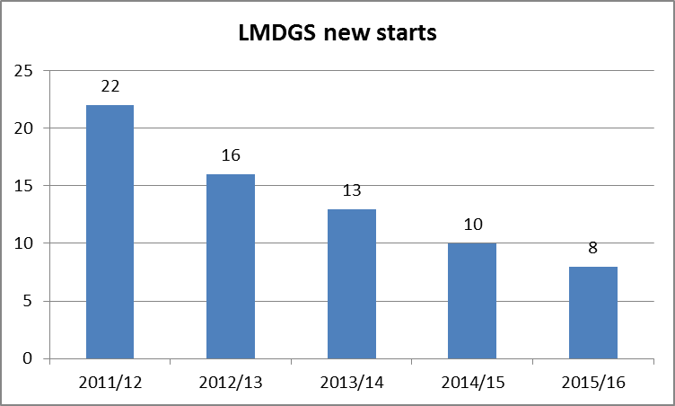

Problems for singles and couples
- The LHA market has shrunk as clients are priced out and landlords fear an increased risk from money loss as the roll out of direct payment to tenants under Universal Credit is implemented. This began in Oxford last year for singles with plans to implement for all families by 2021.

- Single people under 35 only receive an amount equivalent to the cost of a room in a shared house known as Shared Accommodation Rate (SAR) which is £349 a month compared with the valuation agency median rent of £520 in March 2016.

- The LHA rate has now been frozen for four years which results in people finding it harder to make up the difference or face eviction.

- Over half of the reasons for accepted homelessness cases were from the ending of a tenancy in the PRS up from 40% the previous year.

- The SAR rate will also apply to under 35 singles living in social housing in 2018.

- Oxford did not qualify this year for any LHA uplift through the limited targeted affordability fund to help people in areas with high rent increases.

- The number of singles and couples of the Councils housing list is 1118, 4% of whom are under 25 years old.

- This age group and family type traditionally help supply low income public sector and service business jobs. There are indications that employers are reporting recruitment and retention issues for example over half of the City’s Councils 1229 workforce do not live in Oxford partly due to high housing costs.(Internal Human Resource Metrics 2015)

- The barriers to better work opportunities and therefore increase housing affordability include:
High travel costs
Unrealistic expectations
Low skill levels and or confidence
Interaction of job income with benefits

Homeless Duty of Prevention
- Ministers are considering changes to the law in an attempt to support the growing number of people on the brink of homelessness based on the Welsh duty to prevent which says that local authorities have a duty to help secure accommodation for all applicants assessed as homeless irrespective of whether they are in priority need for up to a period of 56 days.

- After this period there is continuing duty for unintentionally homeless households in priority need.

- In exchange households may be required to cooperate with a tailored package of measures such as debt advice, employment help or family mediation either to help them stay in their existing home or find a suitable new home.

- The Government would be likely to be seeking the following outcomes:
Fewer non-priority households experience the trauma of homelessness
Better more targeted prevention work
Increased help advice and information for households to address the causes of homelessness and make informed decisions on finding solutions to their housing problem
More effective use of the PRS as a solution to homelessness

Options for the future of the LMDGS
- Do nothing and await formal Government consultation on the prevention duty. Continue the limited realistic options of shared housing; more financial help from family/friends and moving to cheaper areas. The numbers helped will decline.

- Enhance the scheme by adding an interest-free loan to pay rent in advance in exchange for the household taking steps to improve their financial well-being by saving and income boost engaging with the Councils welfare reform team. This improved offer should fulfil any likely duty to prevent homelessness and produce better outcome outlined above and boost number of clients helped. We would suggest a target of up to 24 new starts in the pilot year. It is emphasised that the enhanced offer is discretionary in each individual case.

- We may also consider a lesser security option of lodging as there was a tax relief boost for resident landlords that may increase supply.

Recommendation
- The trial proposed offer would be :

Singles under 35:
Offer of a bond equating to 6 – 8 weeks at a higher rate of £450 which in the event the landlord was to claim in full would equate to £830.76 if the bond was 8 weeks.
One month’s rent in advance up to £450

Other households:
Offer of a bond equating to 6 – 8 weeks at a rate of £688.57 per month. In the event the landlord was to claim in full would equate to £1271.20 if the bond was 8 weeks.
One month’s rent in advance up to £750

- If we were to reach our target and assist 24 clients over the year the worst case scenario of rent in advance would equate to £18000 based on all applicants being over 35.

- However there would be a mix of ages so this figure would be less. If we were to look at an equal split across the client scenarios the rent in advance sum would equate to £14,400.

- If we were to consider enhancing the offer for the Lord Mayors Deposit Guarantee Scheme we could consider agreeing a repayment plan with the client to repay this loan of rent in advance and engagement with the Welfare Reform Team.

- To mitigate risk we could cap the number of clients we assist to ensure the yearly cost is limited to £15k.

- The standard terms of a loan repayment would be a maximum of 30 months by standing order or direct debit at a rate of at least £15 a month for under 35’s on the lower LHA rate and £25 a month for over 35 year old households. A provision will be available for an agreed extension in cases of hardship. In the event of a significant default the borrower will be referred to the debt collection team. The borrower will have the flexibility to repay the loan early.

Financial implications
- The potential impact on the LMDGS reserve of £50k can be mitigated by quarterly monitoring of bonds and settlements and numbers accepted, suspending the enhanced offer if necessary. After the pilot year, the number of clients assisted and total expenditure will be reviewed and reported annually. In the light of this any necessary amendments will be brought to CEB.

- Legal officers will draw up a standard loan agreement. The risk of defaults on repayment will be mitigated by the conditionality set out in paragraph 26 above.

Legal issues
- There is no current statutory obligation to operate this scheme as its offer is a matter of local discretion.

Level of risk
- There are no known significant changes to risks. See Appendix1

Equalities impact
- There are no known significant equality impacts, other than to improve assistance to single vulnerable persons in need of housing.

- The scheme access to eligibility remains the same and new offer be promoted by digital web and forms available in Council and stakeholder offices

Report author | David Rundle
Job title | Private Rented Sector Team Leader
Service area or department | Housing and Property
Telephone | 01865 252398
e-mail | drundle@oxford.gov.uk

Background Papers: None

